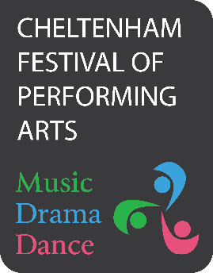
Become a Friend of the Festival

Be our Friend in 2026 and get free spectator entry to all Festival Classes.

We ask for a minimum donation of £30 per person.

I enclose my donation of £…………….… for Festival Year 2026

Name: | Email:
Address:
 | Postcode:

Cheques should be made payable to: ‘Cheltenham Festival of Performing Arts’ Or pay by Bank Transfer - here are the details:
Lloyds Bank, Account Name: The Cheltenham Festival of Performing Arts
Sort Code: 30-98-97
Account Number: 76919363

Your name will be shown in the Programme as a ‘Friend of the Festival’ if this form and payment is received by CFPA by the 15th March 2026

Please send the completed form to: CFPA, 48 Raleigh Close, Churchdown, Glos. GL3 1NT

Gift Aid
Please treat as Gift Aid donations all qualifying gifts of money made: (please tick all boxes)

 | In the last 4 years |  | In the future
Today

I am a UK taxpayer and I would like the CFPA to reclaim the tax on all qualifying donations that I have made, as well as any future donations. I understand that if I pay less income/capital gains tax than the Gift Aid claimed on all my donations in the tax year in which they are received, it is my responsibility to pay any difference. I understand that other taxes such as VAT and Council Tax do not qualify and that the charity will reclaim 25p tax on every £1 that I give.
Signature: | Date:
By signing this form, I agree for the Festival to hold my details in accordance with its Data Protection Policy which can be found on the Festival’s website.

Please remember to let us know of any changes to your tax status, including to your name and address, or if you need to cancel this arrangement.
Registered Charity No. 1157550 email: info@cfpa.org.uk
website: www.cfpa.org.uk

