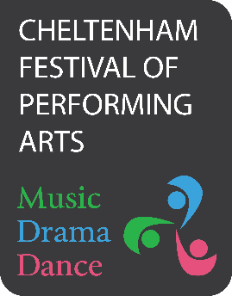

**Become a Friend of the Festival**

Be our Friend in 2025 and get **free spectator entry** to **all Festival Classes.**

We ask for a minimum donation of £30 per person.

I enclose my donation of £…………….… for Festival Year 2025

|  |  |
| --- | --- |
| Name: | Email: |
| Address: |  |
|  | Postcode: |

Cheques should be made payable to: ‘Cheltenham Festival of Performing Arts’ Or pay by Bank Transfer - here are the details:

Lloyds Bank, Account Name: The Cheltenham Festival of Performing Arts

Sort Code: 30-98-97

Account Number: 76919363

Your name will be shown in the Programme as a ‘Friend of the Festival’ if this form and payment is received by CFPA by the 15th March 2025

**Please send the completed form to: CFPA, 48 Raleigh Close, Churchdown, Glos. GL3 1NT**

**Gift Aid**

Please treat as Gift Aid donations all qualifying gifts of money made: (please tick all boxes)

|  |  |  |  |  |
| --- | --- | --- | --- | --- |
|  | In the last 4 years |  | In the future |  |

Today

|  |  |
| --- | --- |
| I am a UK taxpayer and I would like the CFPA to reclaim the tax on all qualifying donations that I have made, as well as any future donations. I understand that if I pay less income/capital gains tax than the Gift Aid claimed on all my donations in the tax year in which they are received, it is my responsibility to pay any difference. I understand that other taxes such as VAT and Council Tax do not qualify and that the charity will reclaim 25p tax on every £1 that I give. | |
| Signature: | Date: |
| By signing this form, I agree for the Festival to hold my details in accordance with its Data Protection Policy which can be found on the Festival’s website. | |

**Please remember to let us know of any changes to your tax status, including to your name and address, or if you need to cancel this arrangement.**

Registered Charity No. 1157550 email: info@cfpa.org.uk   
website: www.cfpa.org.uk